Printable View (38 KB)
Article No.  99-6-5 | - WINDNOISE - AROUND SIDE DOOR(S) - SERVICE TIPS
Publication Date: MARCH 23, 1999

FORD: | 1994-99 CROWN VICTORIA, ESCORT, TAURUS  1995-99 CONTOUR
LINCOLN-MERCURY: | 1994-98 MARK VIII  1994-99 CONTINENTAL, GRAND MARQUIS, SABLE, TOWN CAR, TRACER  1995-99 MYSTIQUE
LIGHT TRUCK: | 1994-97 F-150-350 SERIES  1994-99 ECONOLINE, EXPLORER, RANGER  1995-99 WINDSTAR  1997-99 EXPEDITION, F-250 LD, MOUNTAINEER  1998-99 F-150, NAVIGATOR  1999 SUPER DUTY F SERIES
This TSB article is being republished in its entirety to add model year coverage and specify a standard door weatherstrip service push pin.

ISSUE:
Windnoise from the side doors may be heard on some vehicles. This may be caused by the door weatherstrip seal. This TSB article provides Service Tips for correcting this concern.

ACTION:
Diagnose and repair any windnoise from door weatherstrip concerns using the following Windnoise Service Tips.

WINDNOISE SERVICE TIPS
DO NOT REPLACE THE WEATHERSTRIP UNLESS IT IS:
- Torn
- Ripped
- Cut
- Deteriorated excessively
- Material defect/abnormalities, or
- TSB specifies the replacement of the weatherstrip
NOTE: | REPLACEMENT SHOULD BE DUE TO NORMAL USE, NOT DUE TO CUSTOMER MISUSE.

WEATHERSTRIP WINDNOISE OR APPEARANCE SERVICE TIPS
The following text explains attachment methods for Ford Motor Company's generic repair standards for loose and/or misaligned weatherstrips.

Flanges
are typically used on the body opening where weatherstrip retention fins grab onto each side of the sheet metal flange to retain the weatherstrip with a press fit. In cases where these weatherstrips become loose and/or misaligned, they can be reinstalled by pressing the locking retention fins back onto the sheet metal flange and stretching to provide better retention around corners. If the weatherstrip retention fins or metal carrier become damaged, it is also required that the U-section be carefully bent back into the proper shape to properly lock onto the sheet metal flange. Once replaced, check the weatherstrip for proper retention. If required, Weatherstrip and Rubber Adhesive (E8AZ-19552-A or equivalent meeting Ford specification ESB-M2G14-A) should be applied to the inside of the weatherstrip U-section to bond with the sheet metal flange for proper retention force.

Sheet Metal C-Channels
are typically used on the upper perimeter of the door assembly or body panel to hold the weatherstrip molded base inside the C-channel. In cases where these weatherstrips pop out of the channel, repair by first removing the weatherstrip from the entire channel, and reassemble by sliding the molded base back into the channel. If the sheet metal channel has been damaged, it is also required that the C-channel be carefully bent back into the proper shape to retain the weatherstrip molded base.

Push Pins
are typically used on the lower perimeter of the door assembly attached to the weatherstrip. They are press fit into sheet metal holes for retention. Push pins can be gently removed by pulling the actual pin normal to the surface, out of the hole, and reinserted without damage. If a push pin is damaged, it should be replaced by first removing the existing push pin. Then, the base of a new push pin should be inserted into the weatherstrip hole, and finally press fit into the corresponding sheet metal hole. All door perimeter weatherstrip push pins should be repaired using Ford standard N806340-S.

Rivets
are used to attach some weatherstrips to the sheet metal body. In cases where a rivet becomes loose, the entire rivet should be removed and replaced with a new rivet.

Adhesive Tape
is used to adhere smaller weatherstrip sections to the painted sheet metal surface. All surfaces must be clean and dry before any weatherstrip reattachment is performed. Adhesive tears should be reattached to the painted surface using general purpose Instant Adhesive (E8AZ-19554-A or equivalent).

VERIFICATION
- If the weatherstrip is not attached properly, reattach it correctly.
- If the condition of the weatherstrip is good and it is attached properly, test drive the vehicle to diagnose the root cause of the windnoise. Verify the sealing contact between the door and the weatherstrip is sufficient with the 3X5" Card Test or a Chalk Test found in this TSB article.
- If sealing contact between the weatherstrip and the door is the root cause of the windnoise, readjust the doors to contact the weatherstrips.
NOTE: | WEATHERSTRIP REPAIRS SHOULD NOT CREATE UNACCEPTABLE DOOR CLOSING EFFORTS, WINDNOISE CONCERNS, OR WATER LEAK CONCERNS WITH THE DOOR SYSTEM.

3X5" CARD TEST
- Insert a 3x5" card between the door and the weatherstrip at the base of the A-pillar with the door closed.
- Run the card up along the A-pillar.
If the card easily moves at any location along the A-pillar, then the sealing contact between the door and the weatherstrip is insufficient and the door should be adjusted to increase the sealing contact. This test can only be used to evaluate the A-pillar sealing contact at the margin. To evaluate sealing contact of the primary and secondary weatherstrips, a Chalk Test must be performed.

CHALK TEST
- Lightly and evenly spray the sheet metal sealing surface of the door and body with a tracing powder (chalk spray).
- Gently close the door, applying pressure only at the latch to prevent overslam (which will give an inaccurate reading).
- Open the door and inspect the seals for degree of compression and possible skips.
To provide adequate sealing contact, the weatherstrip-to-sheet metal contact should provide a tracing powder footprint width of 4-6mm on the weatherstrips. Any skips or tracing powder footprints less than 3mm in width indicate insufficient door-to-weatherstrip sealing contact and the door should be adjusted to increase the sealing contact.

DOOR ADJUSTING
Refer to Figure 1 and Figure 2 .
- The upper and lower door hinges provide sufficient in/out adjustment to increase door contact with the dynamic weatherstrips. The door should not be pried or forced into alignment. To properly correct the door fit to the weatherstrips, the door striker and/or hinge bolts to the door must be loosened and adjusted to perform the alignment procedure. Note that the door striker only controls the in/out location of the door at the rear latch area. The hinges control the in/out location of the door at the front, and the overall tip or tilt of the door when viewed from the front or rear.
- Review the overall fit of the door to the surrounding panels, and the amount of compression of the weatherstrip at all locations around the door. The fitting procedure is mastered sequentially from the rear of the vehicle to the front:
  - from the quarter panel to the rear door
  - from the rear door to the front door
  - then the front door to the fender
All mating surfaces should be reviewed and, if necessary, refit starting with correcting the rear door to the quarter panel and working forward.
- The door should be adjusted to obtain proper seal compression while maintaining a good door fit. An adjustment may be required only at one hinge. For example: if the top of the door is outboard, causing a lack of seal compression around the upper door frame area, and the fit of the lower part of the door is good to the adjacent panels, an inward adjustment at only the upper hinge would be appropriate (refer to Step 5). Note that adjustments to the rear door may require additional adjustments to the front door, and then also possibly to the front fender to maintain the proper panel fit and alignment.
- The rear of the door should be set in/out with the striker to align at the door latch area with the mating panel. If the upper or lower part of the door doesn't align to the adjacent panel, the amount of door tip must be corrected by adjustment at the hinges in order to get both the upper and lower surfaces of the door aligned or flushed to the adjacent panels.
- The in/out setting at the front of the doors is controlled by the hinge adjustment.
  - It should be set to obtain the proper amount of seal contact, which can be determined using the 3X5" Card Test or the Chalk Test.
  - As a guideline, if there is insufficient weatherstrip contact of the door, the hinge(s) should be adjusted 2-4mm inboard. This is accomplished by loosening the hinge-to-door bolts just enough to permit movement of the door with a padded pry bar.
  - Only one hinge should be adjusted at a time. The other tight hinge helps to prevent any drastic door movement (which may result due to the weight of the door) which will result in a complete door refitting for both up/down as well as in/out positions.
  - The amount of movement can be determined by outlining the hinge mounting area on the door prior to adjustment, and measuring the hinge movement relative to this outline after adjustment. A 2-4mm adjustment should be sufficient to return the door to within its nominal operating range.
- Finally, the door closing effort should be checked to be sure the seal compression has not increased so much that a closing effort concern has been created. If the efforts are unacceptably high, the door may have been moved excessively inward, and should be refitted outward to a location that balances the seal compression for windnoise with closing efforts. It may be necessary to perform another 3X5" Card Test or Chalk Test to verify the final seal compression.

PART NUMBER | PART NAME
E8AZ-19552-A | Weatherstrip And Rubber Adhesive
E8AZ-19554-A | Instant Adhesive
N806340-S | Snap-On Push Pin

OTHER APPLICABLE ARTICLES:
NONE

SUPERSEDES:
98-18-5

WARRANTY STATUS:
INFORMATION ONLY

OASIS CODES:
110000, 701000
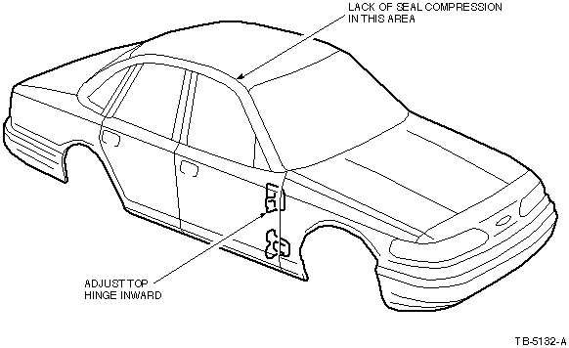
Figure 1 - Article 99-6-5
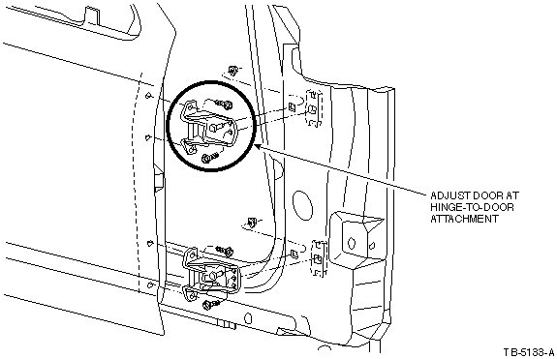
Figure 2 - Article 99-6-5

